**EECS 360**

**Lab 8**

**10/25/16**

**Chen Long**

**Objective**

This lab is about Fourier Transform, we are supposed to use an approximation of CTFT to compare with the actual function to see the difference.

**Description**

We are supposed to increase the period and see what’s happening, at first, we should define the fundamental frequency, M, and so on; then, we need to use the approximate equation, which is x(m*tau)e-j2pifm*tau, once we know x(t), which in this lab is u(t)e-t, we then do a summation of it. The code should look like this, sum=sum+(exp(-1*tau*m)*exp((-j*2*pi*n*m)/M)). After we got the value of sum by running this equation in a for loop, we plot the graph. Since that after we do the Fourier Transform, it will then be in frequency domain, so the x axis should be f.

We then apply the same method to 3 different periods, and plot the phase of each result.

**Result**

The result comes out that while we increase the magnitude of period, the amplitude of the transform will become more and more accurate. The reason is because fo=1/T, while the period is increasing, the frequency is decrease, and since f=-50:fo:50, we are basically sampling frequency more and more accurate. For the phase part, we can see there is some difference, but the general graph is close, the reason why this is happening is because I do not apply the step function, which is u(t) into the summation.

**Conclusion**

This lab help me have a better understanding for Fourier Transform, Fourier Transform is from Fourier Series but just a different way of applying the concept. I know now that the period is doing a big part in the Fourier Transform.

**Appendix I**

**Approximation vs Actual function**

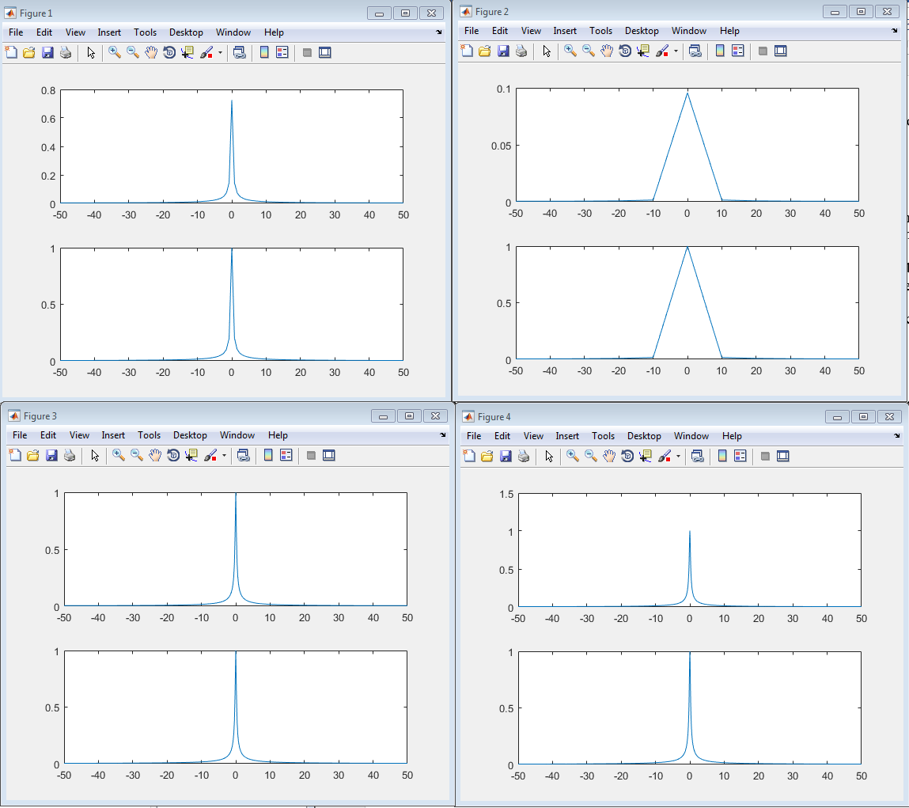

**Magnitude comparison and phase comparison**

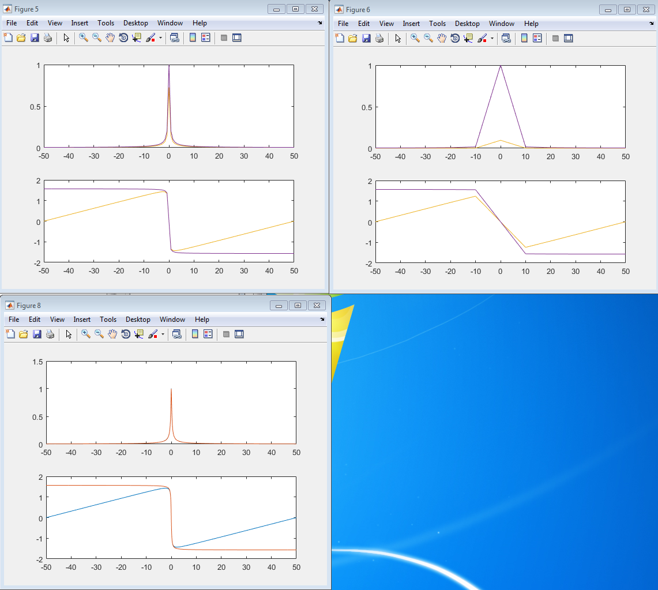

**Appendix II**

**MATLAB CODE**

clear all;

T=1.28;

t=0:0.01:T;

fo=1/T;

tau=0.01;

M=T/tau;

m=0;

f=-50:fo:50;

n=f/fo;

sum=0;

xf=1./(1+(j*2*pi*f));

for m=0:M-1

sum=sum+(exp(-1*tau*m)*exp((-j*2*pi*n*m)/M));

end

sum=tau*sum;

figure(1);

subplot(211);

plot(f,abs(sum));

subplot(212);

plot(f,abs(xf));

% Figure angle

figure(5);

subplot(211);

plot(f,abs(sum)); hold on;

plot(f,abs(xf));

subplot(212);

plot(f,angle(sum)); hold on;

plot(f,angle(xf));

% T = 0.1

figure(2);

sum = 0;

T=0.1;

fo=1/T;

f=-50:fo:50;

tau=0.01;

M=T/tau;

n=f/fo;

sum=0;

xf=1./(1+(j*2*pi*f));

for m=0:M-1

sum=sum+(exp(-1*tau*m)*exp((-j*2*pi*n*m)/M));

end

sum=tau*sum;

subplot(211);

plot(f,abs(sum));

subplot(212);

plot(f,abs(xf));

figure(6);

subplot(211);

plot(f,abs(sum)); hold on;

plot(f,abs(xf));

subplot(212);

plot(f,angle(sum)); hold on;

plot(f,angle(xf));

% T = 5.12

figure(3);

sum = 0;

T=5.12;

t=0:0.01:T;

fo=1/T;

f=-50:fo:50;

tau=0.01;

M=T/tau;

n=f/fo;

xf=1./(1+(j*2*pi*f));

for m=0:M-1

sum=sum+(exp(-1*tau*m)*exp((-j*2*pi*n*m)/M));

end

sum=tau*sum;

subplot(211);

plot(f,abs(sum));

subplot(212);

plot(f,abs(xf));

figure(7);

subplot(211);

plot(f,abs(sum)); hold on;

plot(f,abs(xf));

subplot(212);

plot(f,angle(sum)); hold on;

plot(f,angle(xf));

% T = 12.8

figure(4);

sum = 0;

T=12.8;

t=0:0.01:T;

fo=1/T;

f=-50:fo:50;

tau=0.01;

M=T/tau;

n=f/fo;

xf=1./(1+(j*2*pi*f));

for m=0:M-1

sum=sum+(exp(-1*tau*m)*exp((-j*2*pi*n*m)/M));

end

sum=tau*sum;

subplot(211);

plot(f,abs(sum));

subplot(212);

plot(f,abs(xf));

figure (8);

subplot(211);

plot(f,abs(sum)); hold on;

plot(f,abs(xf));

subplot(212);

plot(f,angle(sum)); hold on;

plot(f,angle(xf));